**GE Lightspeed 16 Slice CT Del Medical U-Arm X-Ray Mindray M7 Ultrasound**

**Our ER is closed, but all equipment is in a new ER.     This is what was in the sales contract when we purchased.   I need a price for one or all three.**

**What price can you offer for this?**

**Brian Kempton**

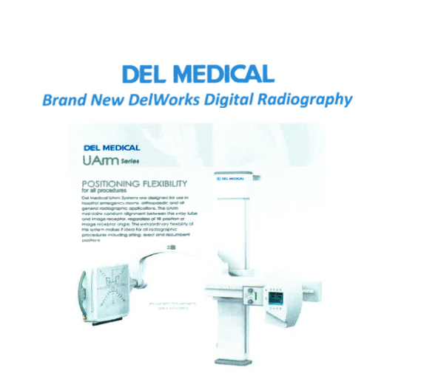

Sent from [Mail](https://go.microsoft.com/fwlink/?LinkId=550986) for Windows 10

